A/B TESTING FOR WEBSITE OPTIMIZATION
Internee.pk Homepage
Data Science Internship — Internee.pk

1. Objective
To design and analyze an A/B test on Internee.pk's homepage in order to identify which version of the page — the current design (A) or a modified design (B) — produces lower bounce rate and higher conversion rate, and to recommend the better-performing version for live deployment.

2. Background — Internee.pk
Internee.pk is Pakistan's virtual internship platform, aimed at bridging the gap between talented students and the country's IT industry. The platform offers virtual internships across 10+ tech tracks (web development, app development, machine learning, data science, and more), along with AI-powered mock interviews, mentorship, and portfolio-building through real, task-based projects. It is a 3x national award-winning platform and is widely used by university students across Pakistan seeking their first industry experience.

3. Test Design

3.1 Primary Conversion Goal
Primary conversion: a visitor clicking the main homepage call-to-action (CTA) button (e.g. “Apply Now” / “Start Your Internship”) that leads toward registration.

3.2 Version A — Control
Version A represents the current live homepage design: existing headline, existing CTA text and color, and the existing layout, used unchanged as the baseline for comparison.

3.3 Version B — Variation
Version B introduces four targeted changes intended to strengthen clarity and urgency without altering the overall page structure:
- A more benefit-driven headline that states the outcome (career, skills) rather than just the platform description.
- A stronger, action-oriented CTA button with a brighter, higher-contrast color.
- Added social-proof bullets (student count, verified certificates) to build trust in the hero section.
- A warmer background tone in the hero section to visually separate it from Version A during testing.

3.4 Homepage Mockups (Screenshots)
Low-fidelity mockups of both versions were prepared for the test, shown below.
Version A — Control
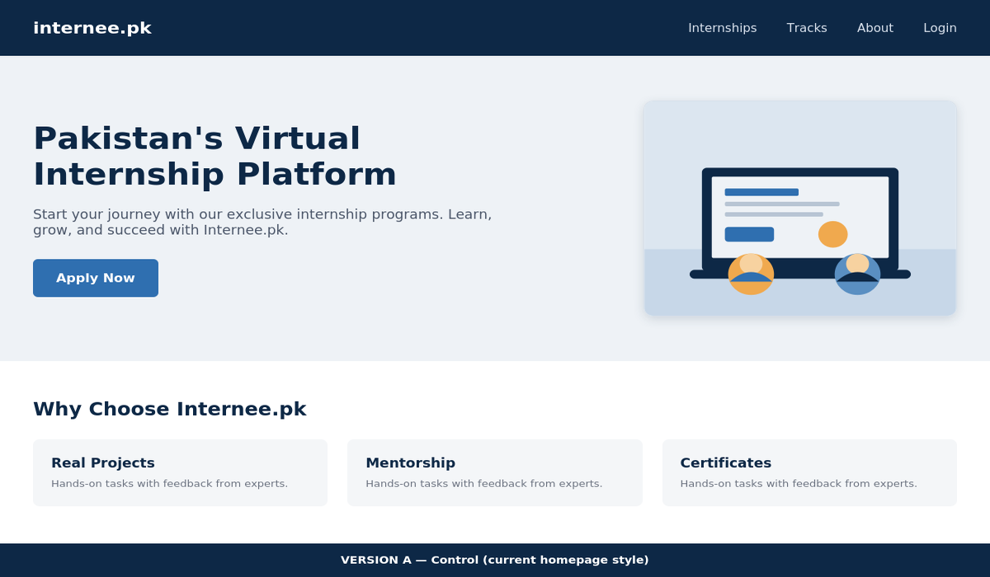
Version B — Variation


3.5 Version A vs. Version B — Comparison
Element | Version A (Control) | Version B (Variation)
Headline | “Pakistan's Virtual Internship Platform” | “Start Your Tech Career — Free Virtual Internships with Internee.pk”
Sub-headline | Start your journey with our exclusive internship programs. Learn, grow, and succeed with Internee.pk. | Join thousands of students building real skills, real projects, and a job-ready portfolio — 100% free and remote.
Main CTA button | “Apply Now” (standard blue button) | “Start Your Internship — Free” (bright orange button, larger size)
Hero section extras | Background image only, no trust indicators | Added benefit bullets: “5,500+ students already registered”, “Verified certificates & real projects”
Background tone | Neutral light-grey hero background | Warm cream hero background, for visual contrast with A during the test

4. Tools & Traffic Allocation
Tracking tool: Crazy Egg / Google Analytics installed on the Internee.pk homepage, used to record visitor behavior such as scroll depth, clicks, and session duration.
Traffic split: Regular visitors arriving via Google search, social media, direct URL, and email links are randomly split 50/50 — half see Version A, half see Version B — so both groups are exposed to comparable traffic sources and volumes during the same test period.

5. Metrics Defined
Bounce rate: the percentage of visitors who leave the site after viewing only the homepage, without any further interaction.
Conversion rate: the percentage of visitors who click the main CTA button on the homepage (the defined conversion goal).

6. Metrics & Data (Assumed / Simulated)
As direct access to Internee.pk's live analytics dashboard was not available, the following realistic, simulated dataset (consistent with typical landing-page A/B test benchmarks) was used for analysis:
Version | Visitors | Bounce Rate | Conversion Rate
A (Control) | 1,000 | 60% | 5%
B (Variation) | 1,000 | 50% | 8%
Change (B vs A) | — | ↓ 10 pts | ↑ 3 pts (+60%)

7. Analysis & Conclusion
Version B reduced the bounce rate by 10 percentage points (from 60% to 50%) and increased the conversion rate by 3 percentage points (from 5% to 8%), a relative improvement of 60% in conversions. This indicates that the clearer, benefit-focused headline, the higher-contrast CTA button, and the added trust signals (student count, verified certificates) made the page more persuasive and reduced early drop-off.
Conclusion: Version B is the stronger performer on both metrics and should be considered the winning variation.

8. Recommendations
- Implement Version B's headline, CTA text/color, and trust-bullet elements on the live Internee.pk homepage.
- Run the test for a longer period (2–4 weeks) with real traffic to confirm statistical significance before a full rollout.
- After rollout, monitor bounce and conversion rates weekly and consider a follow-up test on secondary elements (e.g. testimonials, page load speed).
- Use the same A/B framework for other high-traffic pages, such as the internship listing and application pages.

